**Walmart**

**Case Study**

**Rabecca Ndhlovu**

**Table of Contents**

**Executive Summary3**

**Walmart Strategy4**

Does Walmart have a well-defined strategy4

Walmart generic strategies4

**Five Force Analysis6**

Walmart Five Force Analysis6

Is Industry Attractive to current competitor or new entrants9

**Competitive Strength Assessment9**

Driving forces in retail industry9

Key success factors (KSF)in retail industry11

Walmart competitive advantage in KSFs11

Company that is poise for growth in 3 -5 years12

**Financial Ratio Analysis13**

Walmart Financial ratio analysis13

Walmart, Target and Amazon Financial ratios comparison16

**Variable Rare Inimitable Nonsubstitutable(VRIN)18**

Are Walmart resources and capabilities VRIN 18

Walmart competencies18

Company with greatest competitive power based on resources and capabilities19

**Strength Weaknesses Opportunities and Threats (SWOT) Analysis**20

Walmart SWOT20

**References22**

**Executive Summary**

Walmart has well defined strategy that is focused on providing lower prices and capturing a diverse customer base through its store formats such as its discount store, supercenters, online store, Sam's club. Additionally, it positioned itself as a one-stop shop catering to the preferences and needs of a large demographic. With that being said, Walmart uses a low-cost strategy to gain competitive advantage and remain relevant in the market. The retail industry has a strong bargaining power of buyers, threats of substitutes and competitive rivalry. Therefore, it is less attractive to new entrants and attractive to current competitors or companies in the industry as they have a strong strategy, market share and competitive advantage.

Walmart has the weakest weighted competitive strength in comparison to its competitors target and amazon. Its strongest competitor is amazon with a competitive strength of 8.15. Amazon is more poised for growth due it its diverse business ventures, technology, and innovations. Walmart has weak financial condition and performance compared to Target and Amazon. It only outperforms its competitors in inventory turnover and total asset turnover. Based on this research, Walmart has a core competency in terms of price. Lower prices are the cornerstone of Walmart’s strategy. Distinct competency is the number of stores that it has which are higher than its competitors and located in both rural and urban areas unlike its competitors. Based on the SWOT analysis, Walmart has strengths, weaknesses to improve, opportunities to take advantage of and threats to address. Doing so would make Walmart continue to remain relevant to the retail industry. It would gain a high market share, increase its competitiveness.

**Walmart Strategy**

Every company must have a strategy. “a strategy is the set of coordinated actions that its managers take in order to outperform the company’s competitors and achieve superior profitability” (Thompson et al., 2022). It is an essential element to the success and growth of a company not only in the short term but also in the long term. A company’s strategy must include means through which it will attract customers, be profitable, compete with its competitors, withstand economic conditions and achieve performance targets (Thompson et al., 2022). Walmart has a well-defined strategy with a combination of elements that work together to ensure it sustains its position as one of the giant retailers. It utilizes Its network of physical stores to capture customers using its promise of everyday lower prices. Walmart has positioned itself as a comprehensive one stop shop that offers a range of merchandise such as groceries, pharmaceutical and automotive services. It has a store format that includes Sam's club, discount store, supercenters and neighborhood markets under one Walmart umbrella thus catering to the preferences and needs of a diverse customer base (Choo, 2024). With its lower prices and store formats, Walmart follows a low-cost strategy.

Walmart has an efficient supply chain system that drives costs down, therefore allowing it to offer lower prices. Its supply chain focuses on efficiency and automation. “It is information, and especially information sharing, that lets Walmart constantly increase efficiency at every step, from replenishment planning and production to shipping, distribution, delivery, and stocking. Studying the nuts and bolts of how Walmart uses information—data—to make that happen can help shippers and other retailers optimize their supply chains with digital data sharing” (Vector, 2024). Visibility, transparency and collaboration are at the heart of Walmart supply chain. Walmart invested in technology to make its operations seamless. It uses Radio Frequency Identification tags (RFIT) that can be scanned pallets or boxes from a distance and while they are moving. RFIT improves restocking of products by three percent compared to the use of traditional barcodes. Additionally, Walmart conducts business directly with suppliers and uses “digital vendor managed inventory system called Retail Link that gives suppliers access to real-time store-by-store point of sale data, whether they are making furniture in China or frozen food in California” (Vector, 2024). Thus, Walmart can receive products from suppliers in a timely manner. It has over 210 distribution centers, each handling over 200 trailers per day. It is working further to implement high technology across its distribution centers, mainly its perishable distribution centers, to increase automation and software intelligence. This will increase efficiency in the handling of products and better storage (Guggina, 2024). It has “economies of scale that no company can match. With approximately $573 billion in global revenues and $429 billion in wholesale purchases, the company has incredible buying power. Its infrastructure assets include 210 distribution centers, a fleet of 9,000 tractors, 80,000 trailers and more than 11,000 drivers. Each distribution center is more than 1 million square feet in size and employs approximately 600 personnel unloading and shipping over 200 trailers daily” (Kerr, 2022).

**Five Force Analysis**

**Walmart, Target & Amazon Five Force Analysis**

|  |  |  |
| --- | --- | --- |
| **Force** | **Description** | **Strength** |
| Power of Suppliers | * Number of Suppliers – small suppliers - less power | Weak |
| Bargaining Power of Buyers | * Low Switching cost * Lifestyle changes * New generation of Buyer * Number of locations * Customer loyalty | Strong |
| Threat of Substitute Products | * Price * Product variety * Customer loyalty * Ease of substitution * Product differentiation | Strong |
| Potential of New Entrants | * Customer loyalty * Company Market share * Capital * Regulations * Company Market share | Weak |
| Competitive Rivalry | * Similar capabilities * High exit barriers * Number of locations * e-commerce * Diverse business lines * Economies of scale | Strong |

**Bargaining Power of Suppliers**

The bargaining power of suppliers is the ability of suppliers to influence the terms and conditions of business in their Favor (Thompson et al., 2022). Companies in the retail industry have many suppliers due to the volume and variety of products that they provide. For example, giant companies such as Walmart have 100,000 suppliers (Investopedia, n.d). Due to the huge number of suppliers, each supplier does not have the power to influence a retailer's decisions. Therefore, the bargaining power of suppliers is weak in this industry.

**Bargaining Power of Buyers**

The bargaining power of buyers is the ability of buyers to influence the prices or quality of products or services offered by a company (Thompson et al., 2022). In the retail industry, buyers have low switching costs as they can easily purchase alternative products that suit their preferences and test. The customer may not only look at the price but also the value of the product. If they value it more even if it's expensive than other alternative products, they will buy it. Lifestyle changes such as the number of hours people spend on technology devices, the need for convenience, focus on diet exercise and family values (Booth, 2019) contribute to the buying habits of customers. Customers purchase items that support their lifestyle. The new generation of buyers are now conscious of social issues such as climate change, the need for sustainability, better pay and working conditions. They support companies that operate in an ethical way and promote great values. There are many physical stores in companies in the retail sector (Statista, n.d), making their products very accessible. Companies in this industry have been in existence for years and evolved with time and many customers have been part of that process. Customers have strong loyalty to some retailers due to the prices, customer services, corporate social responsibility etc. Additionally, companies have also built strong brand recognition through their operations. With that being said, the bargaining power of buyers is strong in this industry.

**Threat of Substitute Products**

The threat of substitute products is how easily a company’s product can be replaced by that of other companies in the industry. Price is one of the major determinates if a customer will purchase a product or not. Similar price ranges (Business Insider, n.d) make it easy for customers to buy products as the cost of switching is low. Product variety provides customers with a large choice base, thus more options. Companies in this industry provide products with less differentiation, making it easy to substitute them. There is an ease to substitute products due to their availability and accessibility as there are many physical and online stores (Statista, n.d). Customer loyalty is also high in this industry. The threat of substitution is strong in this industry

**Potential of new entrants**

The potential of new entrants relates to the possibility of new companies entering the market. The retail industry is well established with many companies that have a large market share (CapitalOne, n.d). New entrants may not be able to compete with the existing companies because they lack the capability and resources to implement competitive strategies that can help them gain a competitive advantage. Customers are already loyal to companies, and it would take a lot of resources and time to convince them to switch to a new company in the industry. Additionally, new entrants would require large amounts of capital to establish themselves. There are many regulations that govern the retail industry which may vary from state to state (NIST, 2023). Compliance with these regulations requires more resources which new entrants may find challenging. The potential of new entrants in this industry is weak.

**Competitive Rivalry**

Companies in the retail industry have similar capabilities such as using technology to streamline and promote efficiency in their supply chain, cutting down waste and providing high customer satisfaction. Their high market share of the companies makes it difficult for them to exit the market. The number of locations makes products more accessible to customers. Companies have also mastered the art of diversification, creating more capabilities and a buffer that curses any financial difficulties (Statista, n.d). Due to how large companies are, they have a high economics of scale.

**Industry attractiveness**

This industry is attractive to current competitors despite the strong competitive rivalry, strong bargaining power of buyers and strong threat of substitutes. Companies in this industry have strategies that enable them to make profits, have a competitive advantage and gain market share.

**Competitive Strength Assessment**

**Industry Driving Forces**

Driving forces are the factors that cause change in the competitive condition of an industry. The driving forces in the retail industry are technology, e-commerce, environmental sustainability, customer satisfaction, product category diversification, company values and reputation. Technology has impacted on the way business is conducted in every industry. In the retail industry, computer AI capabilities have enabled companies to predict demands for their products through AI algorithms. These algorithms identify shopping patterns and analyses them, therefore, make predictions on the changes in customer demands. Many retail companies have adopted a self-checkout system that enables efficiency and also increases customer satisfaction (Forbes, n.d). An innovative form of the self-checkout system is the scan and go self-checkout that allows customers to scan products with their smartphones as they shop. “The growth of self-checkout technology is striking. A study by RBR predicts a [90% per year](https://www.nfcw.com/2022/06/21/377580/rbr-more-than-12000-checkout-free-contactless-stores-to-be-in-operation-by-2027/) global increase in self-checkout terminals. This trend is driven by labor shortages, rising wage concerns and a consumer preference for faster, more autonomous shopping experiences” (Forbes, n.d). E – commerce is one of the major changes which is a result of technology. E-commerce has changed the way business is conducted in the retail industry. Through e-commerce, sales are expected to continue growing with a projected 8.8% in 2024. It is expected that 20.1% of sales will be online in 2024 and 23% by 2027. Some of the factors that drive e-commerce are convivence, less costs (shopping, taxes, fees), option to shop as a guest or create an account delivery, website trustworthiness and complicated checkout process (Forbes, n.d). With the rise in climate change concerns environmental disasters and events such as hurricanes, droughts, famine, pollution, etc., the need to be more environmentally conscious and sustainable is greater. Due to their size supermarkets (fall under retail industry) are the major contributors to greenhouse gas emissions. “Supermarkets face sustainability issues on multiple fronts. Firstly, their operations – powering their shops, refrigerators, delivery vans and depots, packaging their products and handling their waste. And secondly, the products they sell have big environmental impacts, whether it’s carbon emissions from shipping them across the world, or issues such as deforestation and water use in their production” (Howes, 2024). Companies in the retail industry need to act on implementing sustainability practices to abide by the laws and regulations and gain more sales from customers who are environmentally conscious. Customer satisfaction is not only limited to the easy and convenient shopping experience that is supported through technology, e=commerce, employee assistance and other services but also sustainability and the values of a company. Customers enjoy the experience of one stop shopping as it allows them to save time. Therefore, companies in the retail industry need to keep up with diversifying their product categories based on the customer's needs. A one stop shopping model promotes economies of scale, customer loyalty, competitive pricing, cross selling opportunities and increased connivence for customers (Dr. Gary Fox, 2024)

**Industry Key Success Factors (KSFs)**

“Key success factors are the strategy elements, product and service attributes, operational approaches, resources, and competitive capabilities that are essential to surviving and thriving in the industry” Thompson et al., 2022). The key success factors determine a company’s ability to either survive or succeed in the industry. The key success factors in the retail industry are price, quality, e- commerce, household brand, customer service, technology, household brand, number of locations and product category diversity.

**Walmart Competitive Advantage (KSFs)**

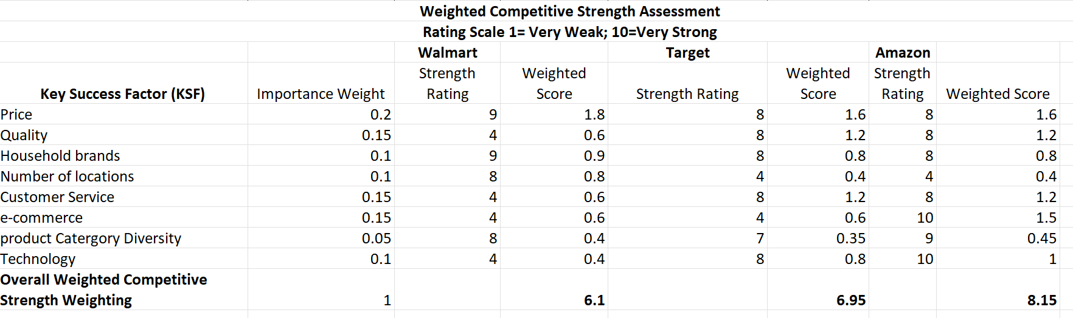

Walmart's competitive advantage with regards to its key success factors is its price, household brands, number of locations, customer service, e-commerce, technology and product category diversity. Walmart has the lowest prices compared it its competitors (Business Insider, n.d). Household brands are a great addition to any retail company. Companies have complete control of their household brands unlike the other brands in their stores. They can regulate prices according to customer demands and the economic conditions. Walmart’s great value household brand offers diverse categories of products. Great value brands offer lower prices compared to their competitors’ household brands (Neubauer, 2024). In comparison to its competitors, Walmart has the highest number of stores, 5320, while Target has 1956 stores (Statista, n.d). Although known mainly for online shopping, Amazon is estimated to have about 629 stores (Howland, 2018). Walmart huge number of locations make it more accessible and convenient for its customers both in urban and rural areas. The company can gain additional sales from locations they're its competitors are not available. Walmart is a one stop shop where customers can access a variety of products in different categories or departments under one roof. It sells over 75 million products (Smith, 2024). On the other hand, Amazon sells over 600 million products (CapitalOne, n.d). The physical location and accessibility of Walmart is what distinguishes it from Amazon. Customers do not have to wait for the product to be delivered but rather can buy it at their local Walmart store. This creates more opportunities for cross-buying or impulse buying, thus more revenue for the company.

**Firm best Poised for Growth**

With a weighted competitive strength of 8.15, Amazon is the strongest rival of Walmart. The company is more poised for growth. Amazon offers more products compared to any other company in the industry. Unlike other companies, Amazon has a diverse business line including products, services and devices. Amazon’s cloud computing services called Amazon Web Services (AWS) that has a market share of about 32% and is the leading provider of public cloud computing services. It also offers digital advertising on and off its platforms such as the Amazon Marketplace, Twitch and Amazon Fire TV. It earns about 8.6% of digital advertising spending the United States (Jennewine, 2020). The diverse business lines in various industries create a buffer for Amazon to thrive and provide more opportunities for it to continue growing. Additionally, Amazon has introduced new innovations that will promote employee efficiency, fast delivery and sustainability. Amazon’s next generation fulfillment center powered by robotics and IA innovation increases packages and shipments efficiency while the AI powered package spotlight systems allow delivery drivers automatically identity the packages to be delivered at each stop thus promoting efficiency. Amazon continues to reduce its waste and packages. It recently removed the plastic air pillows in the packages, reduced each shipment package weight by 43% and 3 million metric ones of waste from packaging. Other innovations include the AI shopping tools on the amazon app and same day delivery for pharmacy products (Staff, 2024)

**Walmart Financial Ratio Analysis**

Financial ratios are an important aspect of a company analysis as they depict the financial condition of a company. The ratios provide a great insight into the performance and market position of a company. The ratios are categorized into sections such as the profitability ratio, activity ratio, liquidity ratio, leverage ratio and other measures of financial conditions. Due to the complexity and variety of financial ratios available, for the sake of this case study, only the ratios listed in the table will be used to analyses Walmart’s financial condition and compare it to that of Target and Amazon. The chosen ratios highlight the profitability, activity ratios, operational performance and liquidity of a company.

|  |  |  |  |  |  |
| --- | --- | --- | --- | --- | --- |
| **Walmart Financial ratios** | | | | | |
| **Ratio** | **2019** | **2020** | **2021** | **2022** | **2023** |
| Return on Assets % | 3.15 | 6.53 | 5.53 | 5.5 | 4.79 |
| Return on Equity % | 8.87 | 20.22 | 17.37 | 16.66 | 14.6 |
| Operating Margin % | 4.27 | 3.93 | 4.03 | 4.53 | 3.34 |
| Net Margin % | 1.3 | 2.84 | 2.42 | 2.39 | 1.91 |
| Inventory Turnover | 41.71 | 41.02 | 38.81 | 43.16 | 44.51 |
| Total Asset Turnover | 2.43 | 2.3 | 2.29 | 2.3 | 2.5 |
| Financial Leverage | 3.02 | 3.17 | 3.12 | 2.94 | 3.17 |
| Earnings Yield % | 4.2 | 4.81 | 1.98 | 2.29 | 3.81 |

|  |  |  |  |  |  |
| --- | --- | --- | --- | --- | --- |
| **Targets Financial ratios** | | | | | |
| **Ratio** | **2019** | **2020** | **2021** | **2022** | **2023** |
| Return on Assets % | 7.32 | 7.81 | 9.29 | 13.22 | 5.19 |
| Return on Equity % | 25.53 | 28.37 | 33.25 | 50.95 | 23.11 |
| Operating Margin % | 5.45 | 5.96 | 6.99 | 8.44 | 3.53 |
| Net Margin % | 3.9 | 4.2 | 4.67 | 6.55 | 2.55 |
| Inventory Turnover | 5.87 | 5.93 | 6.74 | 6.11 | 6 |
| Total Asset Turnover | 88 | 1.86 | 1.99 | 2.02 | 2.04 |
| Financial Leverage | 3.65 | 3.62 | 3.55 | 4.2 | 4.75 |
| Earnings Yield % | 4.87 | 4.27 | 5.88 | 4.91 | 5.51 |

Source: [Morningstar | Empowering Investor Success](https://www.morningstar.com/)

|  |  |  |  |  |  |
| --- | --- | --- | --- | --- | --- |
| **Amazon Financial ratios** | | | | | |
| **Ratio** | **2019** | **2020** | **2021** | **2022** | **2023** |
| Return on Assets % | 5.97 | 7.81 | 9 | -0.62 | 6.14 |
| Return on Equity % | 21.95 | 27.44 | 28.81 | -1.92 | 17.49 |
| Operating Margin % | 5.18 | 5.93 | 5.3 | 2.38 | 6.41 |
| Net Margin % | 4.13 | 5.53 | 7.1 | -0.53 | 5.29 |
| Inventory Turnover | 28.44 | 24.16 | 25.52 | 27.41 | 25.7 |
| Total Asset Turnover | 1.45 | 1.41 | 1.27 | 1.16 | 1.16 |
| Financial Leverage | 3.63 | 3.44 | 3.04 | 3.17 | 2.6 |
| Earnings Yield % | 1.22 | 1.05 | 1.53 | 1.31 | 1.26 |

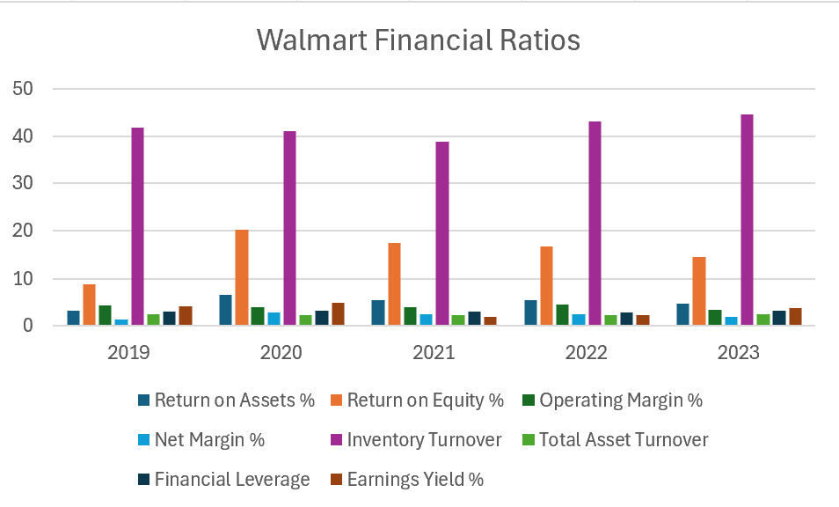

Graphs created by Rabecca Ndhlovu

Returns on assets determine how a company’s profits relate to the assets it used to generate them (Investopedia, n.d). Walmart’s returns on assets have generally been steady. It recorded the highest returns on assets at 6.53 in 2020 and the lowest at 3.15 in 2019. Walmart is efficient at using its resources to generate profit. The higher the returns on assets the more efficient a company is. The decline in returns on assets from 2021 to 2023 indicates that it took a little bit more assets to generate the profit. Thus, there is room for Walmart to improve its management of assets. The return on equity has faced a steady decline from 2020 to 2023 with the highest decline in 2023. Walmart is getting less efficient at generating equity to generate profits. Its performance is slowly declining, therefore affecting its future growth (Investopedia, n.d). The amount of money that Walmart makes in each dollar sale after subtracting production cost has been fluctuating. This shows how Walmart is struggling to manage its cost of good and variable costs of production. The net margin has generally been increasing with minimal declines; therefore, the profitability of Walmart has been stable. Walmart’s inventory turnover indicates its strong sales, high product demand, great strategy and marketing for its products. The company's products are replaced at a faster rate, except for 2022 in which it experienced a decline. The values of sales relative to the value of assets, which is known as total asset turnover, have been constant overall. The minimal fluctuations with the highest total asset turnover of 2.5 in 2023 depict Walmart’s potential to efficiently generate more sales from every dollar in assets. The financial leverage of Walmart has been decreasing with the highest record in 2020 and 2023 of 3.17. The increase in debt in 2020 is because of the COVID 19 pandemic which negatively impacted many companies across the globe (Investopedia, n.d). Financial leverage can be used as an investment strategy to fund projects, promote growth and gain market buying power. Its financial leverage has generally been steady while its earning yield has been declining.

**Comparing the Financial Ratios for the Three Competitors in the retail Industry**

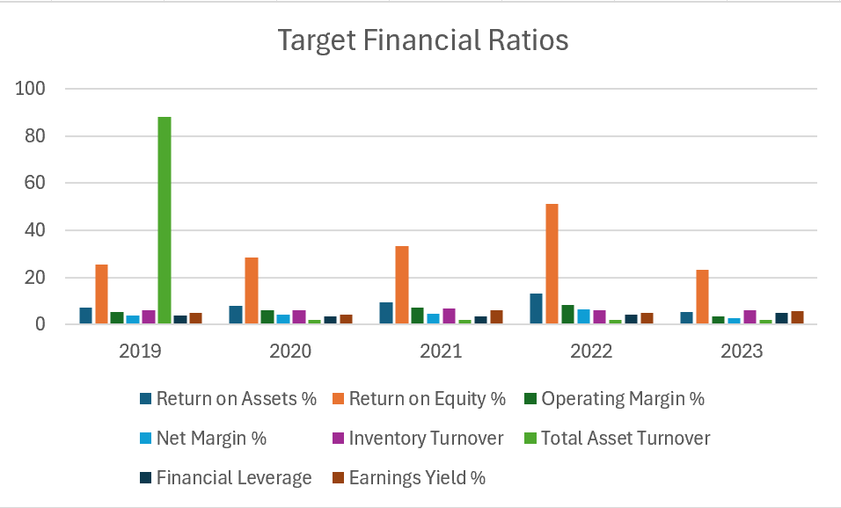

Graphs created by Rabecca Ndhlovu

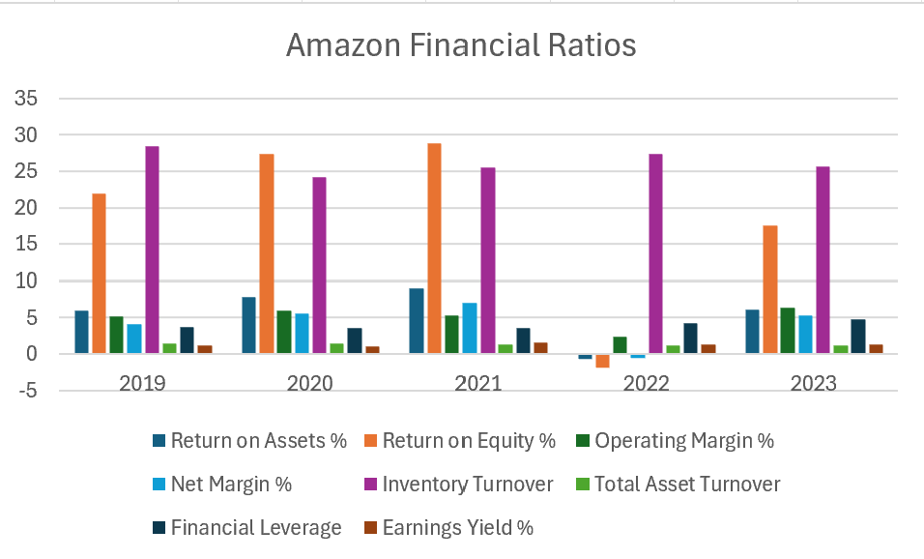

Graphs created by Rabecca Ndhlovu

In comparison to its competitors, Walmart has a poor return on assets while Target has the highest. Target has an increasing return on assets; thus, it is better at managing its resources or assets to generate profits. Target has the highest and increasing return on assets compared to Amazon and Target. Amazon is the second most efficient at generating profits from its equity. The increase in returns on equity makes shareholders more confident to invest in Amazon and promotes future growth. However, high returns on equity can indicate excessive debt. The plumet in Amazon’s return on equity in 2022 is due to an investment in Rivian Automotive RIVN in the automotive sector. The company “first invested $700 million into the electric vehicle (EV) startup in 2019. RIVN stock went public via a special purpose acquisition company (SPAC) late last year and has since lost nearly 75 percent of its value. Altogether, Amazon has lost a reported $7.6 billion in its Rivian venture so far “(Curry, 2022). In terms of cost management, Target is better at it. It has continuously reduced its costs, thus an increase in operating margins. With the aim of reducing costs, the company moved distribution centers to stores so that customers can pick up goods from the store or they can be delivered to customers' vehicles by target employees. It has invested in technology to automate some procedures such as shipping to reduce human errors (Britt, 2020). Walmart has the lowest and most fluctuating operating margins. When it comes to net margins, Amazon has the highest and most increasing margins except in 2022 when it recorded a negative get margin. The increasing net margin can be because of both an increase in sales and control of costs (operating and overhead costs). Walmart has an increasing inventory turnover. This could be due to the marketing strategy, prices, inventory restock level that aligns with customer demands, inventory management strategy and ability to sell inventory (stock data-online, n.d). Total asset turnover is the highest for Walmart followed by Target then Amazon. Target increasing financial leverage signifies the company’s use of debt was a way to finance its investments or projects which would lead to growth instead of issuing stock to raise capital. Finally, Target has the most increasing earning yield. Targets generate higher earnings per share from each dollar invested.

**Walmart Valuable Rare Inimitable Nonsubstitutable (VRIN)**

Walmart has a core competency in price. Its lower price strategy enables it to gain more in sales. Its strategy such as an efficient supply chain enables it to continue offering lower prices even in bad economic conditions. Walmart on average offers the lowest prices compared to its competitors. However, with the innovation and diversification of its competitors such as Amazon, Walmart’s price strategy may be at great risk. With its portfolio, Amazon has more resources and capabilities to compete against the lower prices by offering lower prices or providing better customer service or quality of service/product. Amazon’s technology innovations are reducing its cost thus, enabling it to reduce costs. The number of locations is Walmart’s distinctive competency. Walmart has a higher number of stores than its competitors spread across both rural and urban areas. This makes Walmart more accessible to customers.

**Company with greatest competitive power based on resources and capabilities**

Amazon has the greatest competitive power based on its resources and capabilities. It utilizes technology to provide better working conditions and services for its customers. Amazon has a diverse range of products, making it a one stop online store. It uses data analytics tools that provide great shopping experience such as product suggestions, products that are bought together based on the data from previous customers' purchases. IA shopping guide on the amazon app makes shopping an easy experience.

**Strengths, Weaknesses, Opportunities and Threats (SWOT) Analysis**

**Walmart’s SWOT Analysis**

|  |  |
| --- | --- |
| **Strengths**   * Price * Household brand * Number of locations * Product category diversity * Inventory turnover | **Weaknesses**   * Quality * Customer Service * E-commerce * Technology |
| **Opportunities**   * Diverse business line * e-commerce shopping experience * product differentiation * Adjust to lifestyle changes * Sustainability ventures * Leverage economies of scale | **Threats**   * Foreign/local market share * Technology adaptation * Company values and reputation * Customer loyalty/service |

Based on the SWOT analysis, Walmart has strengths, weaknesses to improve, opportunities to take advantage of and threats to address.

**Opportunities**

In comparison to its competitors such as amazon, Walmart has a less diverse business model. The company has not penetrated in other industries like Amazon such as the technology, entertainment, computer service and retail industry. Utilize its online store to drive more sales by improving customer shopping experience, for instance use of data analytics to recommend products to customers. It can adjust to lifestyle changes by providing products that align with lifestyle change, for instance, more healthy food products and gadgets. As the impact of climate change becomes more prevalent, the need for companies to continue investing in sustainable practices is vital. Thus, gaining more sales especially from customers who are sustainable conscious. Additionally, due to its size it has a large economics of scale which it can leverage to drive product differentiation and offer a variety of products. It can accomplish this with its household brand because it can total control over it.

**Threats**

According to Statista, the number of Walmart stores has been declining (Statista, n.d). Thus, there is a need for Walmart to penetrate more foreign and local markets. This can prevent it from facing financial hardship should its current market face economic struggles such as recession. Additionally, technology has changed the attitude of customers as customer review, shopping personalization and live conversation with potential customers have become more frequent (Forbes, n.d). Walmart needs to continuously adapt to technological changes and leverage customer feedback to impact campaigns that meet the preferences and needs of customers. Thus, increasing customer satisfaction. Additionally, with a more conscious society and the high use of technology such as tik Tok, the company should trickly uphold its values and reputation and operate in an ethical manner. Although wise it may risk losing loyal customers and resources that would otherwise be invested in other sectors of the company. For instance in 2019, Walmart made a payment of $ 282 million to Securities and Exchange Commission for “for violating of the Foreign Corrupt Practices Act (FCPA) failing to operate a sufficient anti-corruption compliance program for more than a decade as the retailer experienced rapid international growth” (U.S. Securities and Exchange Commission, 2019).

**References**

Britt, H. (2020, July 13). *How target ensures its supply chain never misses the mark*. Thomasnet® - Product Sourcing and Supplier Discovery Platform - Find North American Manufacturers, Suppliers and Industrial Companies. https://www.thomasnet.com/insights/target-supply-chain/?msockid=35c1814e974f6fa62044950d96be6e02

Business Insider. (n.d.). *Latest News in Tech, markets, Economy & Innovation*. https://www.businessinsider.com/

Capital One Shopping. (n.d.). *You’ll never have to wait for a sale again.* https://capitaloneshopping.com/lp/shoppingdeals?utm_source=Panda&utm_campaign=1235851347938378&utm_network=o&utm_kwd=kwd-77240928131332%3Aloc-4093&utm_loc=104829&utm_term=77240882030874&utm_type=b&utm_nat=usa&utm_lava=01-0000%3Fmsclkid

Choo, J. (2024, January 5). *Walmart business strategy: A comprehensive analysis*. THE STRATEGY JOURNEY. https://strategyjourney.com/walmart-business-strategy-a-comprehensive-analysis/

Curry, R. (2022, April 29). *Amazon is losing money in 2022-here’s why*. Market Realist. https://marketrealist.com/p/why-is-amazon-losing-money/

Dr. Gary Fox. (2024, July 17). *One-stop-shop business model pattern*. https://www.garyfox.co/patterns/one-stop-shop/

Forbes. (n.d.). *Forbes*. https://www.forbes.com/

Guggina, D. (2024, July 10). *Walmart’s Grocery Network Transformation: The next steps on our supply chain modernization journey*. Walmart. https://corporate.walmart.com/news/2024/07/10/walmarts-grocery-network-transformation-the-next-steps-on-our-supply-chain-modernization-journey

Howes, O. (2024, July 24). *Supermarkets and the environment*. Which? https://www.which.co.uk/reviews/shopping-sustainably/article/supermarkets-and-the-environment-ahzAC2s22tXv

Howland, D. (2018, October 17). *Amazon store count tops 600*. Retail Dive. https://www.retaildive.com/news/amazon-store-count-tops-600/539882/

Investopedia. (n.d.). Investopedia. https://www.investopedia.com/

Jennewine, T. (2020, December 12). *How Amazon’s diverse businesses help it thrive*. The Motley Fool. https://www.fool.com/investing/2020/12/12/how-amazons-diverse-businesses-help-it-succeed/?msockid=35c1814e974f6fa62044950d96be6e02

Kerr, T. (2022, March 1). *Walmart has the scale and infrastructure to generate positive gains*. Yahoo! Finance. https://finance.yahoo.com/news/walmart-scale-infrastructure-generate-positive-201822628.html

Morningstar. (n.d.). *Morningstar | Empowering Investor Success*. https://www.morningstar.com/

Neubauer, B. (2024, June 14). *Target’s good & gather vs. Walmart’s great value: How these 7 grocery staples compare in price*. GOBankingRates. https://www.gobankingrates.com/saving-money/food/target-good-and-gather-vs-walmart-great-value-how-grocery-staples-compare-price/

NIST. (2023, May 11). *Laws and regulations resources*. https://www.nist.gov/pml/owm/laws-and-regulations/laws-and-regulations-resources

Smith, C. (2024, July 17). *Walmart*. DMR. https://expandedramblings.com/index.php/walmart-statistics/

Staff, A. (2024, October 9). *Amazon announces 7 new innovations that power your shopping and delivery experience*. Amazon’s 7 innovations that power your shopping and delivery experience. https://www.aboutamazon.com/news/operations/amazon-innovations-ai-robotics-delivery-sustainability

Statista. (n.d.). *The Statistics Portal*. https://www.statista.com/

stock data.online. (n.d.). *Walmart Inc (WMT)*. Stock Data Online. https://stock-data.online/stock/wmt/activity-ratio/inventory-turnover

Thompson, A. A., Peteraf, M. A., Gamble, J. E., & A.J. Strickland III, A. J. (2022). *https://www.mheducation.com/* (23rd ed.). McGraw Hill LLC.

U.S. Securities and Exchange Commission. (2019). *Walmart charged with FCPA violations*. https://www.sec.gov/newsroom/press-releases/2019-102

Vector. (2024, November 6). *Walmart’s Supply Chain: A detailed look at how they manage it*. https://www.withvector.com/blog/walmarts-supply-chain-a-detailed-look-at-how-they-manage-it/

|  |  |  |  |  |  |  |
| --- | --- | --- | --- | --- | --- | --- |
| **Case Analysis: 150 points** | |  |  |  |  |  |
| **Element** | **Points** | **High 90-100%** | **Medium 70-89%** | **Low 60-69%** | Unacceptable < 59% | **Points Earned** |
| Executive Summary | **Add** up to 10 points | **Previews key points completely yet concisely; captures, holds reader's interest throughout.** | Previews most key points adequately; elicits some reader interest. | Executive summary does not adequately summarize key points. | Executive summary omitted entirely or seriously deficient. | 9 |
| Use of APA format | Add up to 10 points | **Paper includes title page. Paper includes reference page as needed. Paper includes appendices as needed. Uses APA format correctly.** | Paper includes title page. Paper includes reference page as needed. Paper includes appendices as needed. Uses APA format correctly. | Paper missing title page. Paper missing reference page. Paper missing appendices. Does not use APA format correctly. | Paper missing title page. Paper missing reference page. Paper missing appendices. Does not use APA format correctly. | 10 |
| External Analysis | **Add** up to 50 points | **Exceptional background of firm's industry. Analysis of external factors complete. Key external opportunities & threats clearly identified. Relevant high quality research supports analysis.** | Industry analysis could have been more complete and/or clear. Included some key analytical tools. Some key opportunities and/or threats overlooked. Analysis could be improved with additional supporting research. | Industry analysis lacks depth. Competitive analysis is minimal. Missing key analytical tools. Research is lacking or of questionable value | Analysis of the firm's industry, market threats and opportunities is missing entirely or unacceptable | 50 |
| Internal Analysis | **Add** up to 70 points | **Complete internal analysis including ratio, SWOT and other analytical tools. Key internal strengths and weaknesses are clearly identified; relevant high quality research supports analysis. Analysis is consistent throughout the paper.** | One or two key strengths and weaknesses overlooked or not treated in sufficient depth. Included some analytical tools. More research could have been used to support your arguments. Analysis is has some inconsistencies throughout the paper. | Internal analysis lacks sufficient depth. Missing some key analytical tools. Research is minimal and/or of questionable value. Analysis is not consistent throughout the paper. | Specific strengths and weaknesses not identified. Used few or no analytical tools. No research was done. Analysis is not consistent throughout the paper. | 68 |
| Appendices and Exhibits | **Add** up to 10 points **(2 points per table)** | **Exhibits and tables comply with accepted rules for presentation of data; make "dense" verbiage easier to comprehend.** | Some minor errors in the exhibits' presentation of data; information contained in exhibits could be more clear | Significant errors made in presentation of data; some conflict or inconsistency with body of paper | Key tables/appendices are omitted | 10 |
| Use of sources and APA Format | **Subtract** up to 100 points | **Attributes paraphrases and quotes to sources; provides an APA-compliant "References" page. Paper includes title page. Uses APA format correctly.** | Occasional failure to acknowledge sources correctly; two or fewer APA violations. Paper includes title page. Paper includes reference page as needed. Paper includes appendices as needed. Uses APA format correctly. | Multiple instances of failing to acknowledge sources correctly; three or four APA violations. Paper missing title page. Paper missing reference page. Paper missing appendices. Does not use APA format correctly. | Extensive, obvious plagiarism; more than five APA violations. Paper missing title page. Paper missing reference page. Paper missing appendices. Does not use APA format correctly. | 0 |
| Technical skills | **Subtract** up to 20 points | **Grammar, spelling, punctuation correct or very minor errors** | Some grammar, punctuation, and/or spelling errors; more proofreading needed | Numerous and/or serious composition errors; failure to use spell-check | Unacceptable; composition errors extensive | 0 |
| Readability | **Subtract** up to 20 points | **Logically organized, good flow, easy to read and follow; section headings are especially clear and helpful to the reader** | Organization is a bit "choppy;" precise meaning unclear at times; uses headings to separate sections | Organization is hard to follow at times; meaning less clear than desirable; some section headings missing | Meaning is often unclear; omits section headings | 0 |
|  |  |  |  |  | **Total** | **147** |